A new look at the last decade of research on the rise of harmful airborne cyanobacteria and microalgae and its broad consequences

Kinga Wiśniewska1,✉, Sylwia Śliwińska-Wilczewska2, and Anita U. Lewandowska3

1 Department of Climatology and Atmosphere Protection, Faculty of Earth Sciences and Environmental Management, University of Wroclaw, Kosiby 8 St., 51–621 Wroclaw, Poland  
2 Division of Marine Ecosystems Functioning, Faculty of Oceanography and Geography, University of Gdańsk, Al. Marsz. Piłsudskiego 46, 81-378 Gdynia, Poland  
3 Division of Chemical Oceanography and Marine Geology, Faculty of Oceanography and Geography, University of Gdańsk, Al. Marsz. Piłsudskiego 46, 81-378 Gdynia, Poland

✉ Correspondence: [Kinga Wiśniewska <[kinga.wisniewska@uwr.edu.pl](mailto:kinga.wisniewska@uwr.edu.pl)>](mailto:kinga.wisniewska@uwr.edu.pl)

# Abstract

Human-induced environmental changes can synergistically promote the spread and growth of potentially harmful cyanobacteria and microalgae in the atmosphere. On the other hand, we should not forget the role of these microorganisms on the climate change. This is important topic because our decade-long research has shown the year-round presence of cyanobacteria and microalgae in the atmosphere. The present study identifies the relationships between processes occurring in the sea, the primary source of cyanobacteria and microalgae, and their presence in the atmosphere. Furthermore, this review highlights which scientific techniques, known from studies on other bioaerosols, are worth applying in the research on airborne cyanobacteria and microalgae. We also present the future prospects of the studies in the context of advancing machine learning techniques. Moreover, we identify the most favorable and unfavorable time of the year for human exposure to cyanobacteria and microalgae. We prove that cyanobacteria and microalgae are dominant in the air in the summer months, when tourism is actively developing. We also examine the impact of inhaling airborne cyanobacteria and microalgae on human health, not only as potential allergens but also as organisms capable of transferring harmful toxins. This study summarizes research conducted over the past ten years in the Baltic Sea region with new unpublished data as well as incorporates the latest global research trends in Central Europe.

# Introduction

Bioaerosols are a diverse group of microorganisms and their fragments released into the atmosphere from aquatic and terrestrial environments. This group includes bacteria, viruses, fungi, pollen, cyanobacteria, and microalgae1–4. Despite growing interest in airborne cyanobacteria, microalgae, and their associated toxins, most aerobiological research continues to focus on pollen, bacteria, and fungi. As a result, airborne cyanobacteria and microalgae remain among the least understood groups in aerobiology2,4.

Recently, the concept of air eutrophication has gained attention, highlighting the link between anthropogenic activities, water eutrophication, and air quality5. This framework underscores how human-induced environmental changes—including water excessive nutrient enrichment, global warming, air pollution, and artificial light at night—can collectively promote the spread and proliferation of airborne cyanobacteria and microalgae. Beyond ecological consequences, air eutrophication may pose risks to human health through inhalation of airborne toxins such as microcystin-LR (MC-LR), emphasizing the need for urgent interdisciplinary research to understand its mechanisms and impacts.

Research on atmospheric cyanobacteria and microalgae typically begins with identifying their taxonomic composition. Studies in this field can be broadly categorized into those that focus on taxonomic identification and relative proportions of these microorganisms and those that quantify their abundance6–8. Identifying the taxonomic composition is crucial for assessing potential health risks associated with these organisms3,4. Additionally, some studies explore the environmental factors influencing their presence [9; **10**;11;12]. However, further investigation is needed to fully understand the health and environmental impacts of airborne cyanobacteria and microalgae.

One of the main challenges in this field is accurately quantifying cyanobacteria and microalgae in the atmosphere due to limitations in research techniques and the absence of standardized methodologies4. Guiry et al.13 suggested that the number of identified airborne taxa is significantly underestimated, with many species yet to be described. Moreover, some regions remain unexplored in this context4. Since the publication of Wiśniewska et al.4, research in this field has expanded considerably, with new studies emerging from e.g., France14, Slovakia15, and Canada16.

This study aims to address three key issues. First, it examines the relationship between climate change, particularly global warming over the past decade, and the year-round presence of cyanobacteria and microalgae in the atmosphere. Second, it investigates the meteorological factors influencing airborne cyanobacteria and microalgae in the Baltic Sea region, along with their physiological characteristics and possible adaptations. This analysis identifies periods of heightened and reduced human exposure risk in the area of eutrophicated water reservoirs. Third, it explores the potential health impacts of inhaling airborne cyanobacteria and microalgae, expanding beyond their role as potential allergens to their capacity for transferring harmful toxins and other substances into the human body. Finally, the study outlines future research directions, including the potential application of machine learning to better understand the ecological significance of airborne cyanobacteria and microalgae and their effects on human health and climate.

# Results

## Global warming and the year-round Presence of cyanobacteria and microalgae in the air

The rise in air temperature is a well-documented scientific phenomenon observed on both regional and global scales17–19. In the Baltic Sea region, temperature increases have been particularly pronounced, surpassing the global average. For example, in Poland (Central Europe), the mean air temperature has risen by 0.28°C per decade over the past 71 years, amounting to an overall increase of approximately 2°C20. Similar trends have been recorded across the Baltic region since the late 19th century, with annual mean temperatures rising faster (0.08°C) than the global average (0.05°C)21. The increase is accompanied by large multidecadal variations, in particular during winter, but the warming is seen for all seasons and is largest during spring. These climate change have already led to significant environmental shifts, such as reduced ice cover duration and an extended phytoplankton growing season, which has more than doubled in the Baltic Proper—from 110 days in 1998 to 220 days in 2013 while excluding the shallow coastal areas and up to 284 days between 2014 and 2017 including shallow waters19,22.

Warmer conditions, coupled with anthropogenic nutrient loading, have intensified phytoplankton blooms in the Baltic Sea18,23,24, highlighting the direct link between climate change and nutrient-driven ecosystem imbalances. While the Baltic Sea provides a regional case study, eutrophication is a global issue affecting coastal and inland waters worldwide. Recent global assessments using satellite-derived chlorophyll-*a* measurements have identified over 1 million km2 of coastal waters exhibiting potential eutrophic conditions, with deteriorating trends far outweighing those showing signs of recovery25. Both water eutrophication and rising air temperatures contribute to the concept of air eutrophication, a process that facilitates the presence and spread of cyanobacteria and microalgae in the atmosphere5.

Building on this knowledge, we hypothesized that an extended phytoplankton growing season in the Baltic Sea could result in the year-round presence of airborne cyanobacteria and microalgae along the coastal zone, including winter months. This assumption is supported by research conducted in 2020 by Wiśniewska et al.12. The year-long study, spanning from January to December 2020, confirmed the presence of airborne cyanobacteria and microalgae from six distinct phyla (Cyanobacteria, Chlorophyta, Heterokontophyta, Dinoflagellata, Haptophyta, and Charophyta) over the urbanized southern Baltic Sea region. Based on their frequency, these organisms were categorized into four main groups: Cyanophyta, Chlorophyta, and others12. To validate these findings, we incorporated in the study the data from our other published works within the region, starting in 20157,26 as well as previously unpublished data obtained in 2018 and 2019 (Fig. 1). In 2020, research was conducted throughout the year. Monthly observations consistently confirmed the year-round presence of cyanobacteria and microalgae (Fig. 1a,b), even during the winter months.

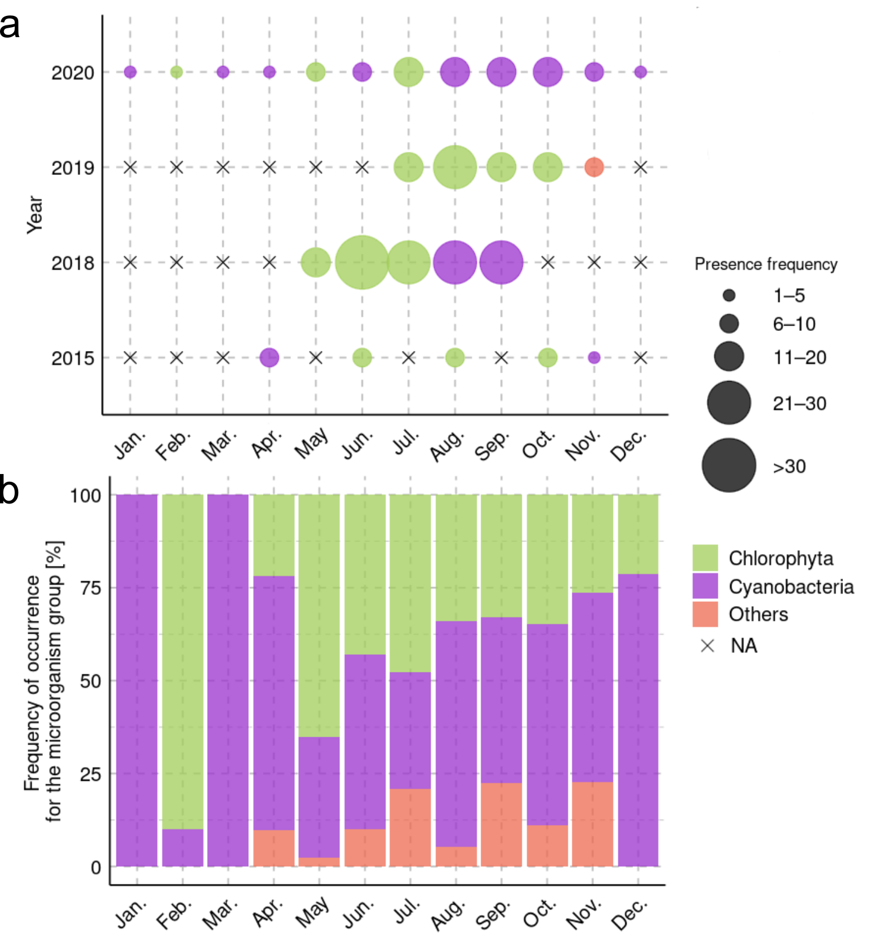

**Fig.** 1: The presence of cyanobacteria and microalgae in the air throughout the year. a The dominant division and frequency of the presence of airborne cyanobacteria and microalgae during the measurement period. Here, a year-long analysis (i.e. sampling every month) was conducted in the southern Baltic Sea in 2020. In previous years, research was conducted in selected months while months for which no research was conducted were marked as NA. b The percentage share of individual groups of airborne cyanobacteria and microalgae collected in southern Baltic Sea coast from 2015 to 2020.

Interestingly, although the presence of these microorganisms, at least in coastal regions, is closely linked to meteorological factors, particularly air temperature. Their winter presence has also been confirmed in Bratislava15, however no significant seasonal differences in abundance were recorded by authors. In contrast, in coastal areas, seasonality is highly pronounced, likely due to the sea being a major source of these microorganisms. Our data from 2020 confirms that the abundance of airborne cyanobacteria and microalgae is also influenced by sea temperature (Spearman rank correlation coefficient 0.559, *p* > 0.05) and, to the same extent, by primary production in the aquatic environment (Spearman rank correlation coefficient 0.559, *p* > 0.05) (Fig. 2, Fig. 3). Although the peak of primary production in the Baltic Sea occurred before the peak abundance of cyanobacteria and microalgae in the atmosphere, the variability pattern confirms that, particularly from November to March, the number of organisms in the atmosphere is closely linked to primary production in the sea. Interestingly, the highest number of cyanobacteria and microalgae cells in 2020 was recorded in July—after the peak increase in phytoplankton but before the peak growth of cyanobacteria. July was the month when a high taxonomic diversity was noted in the atmosphere, without the dominance of any particular group (Fig. 2). This indicates that the maximum number of cells in the air occurred in the middle of the cycle—when the amount of cyanobacteria cells in the sea was high (approaching its maximum in August). In addition to that the concentration of phytoplankton, including other microalgae, remained high as it stabilized after the spring peak.

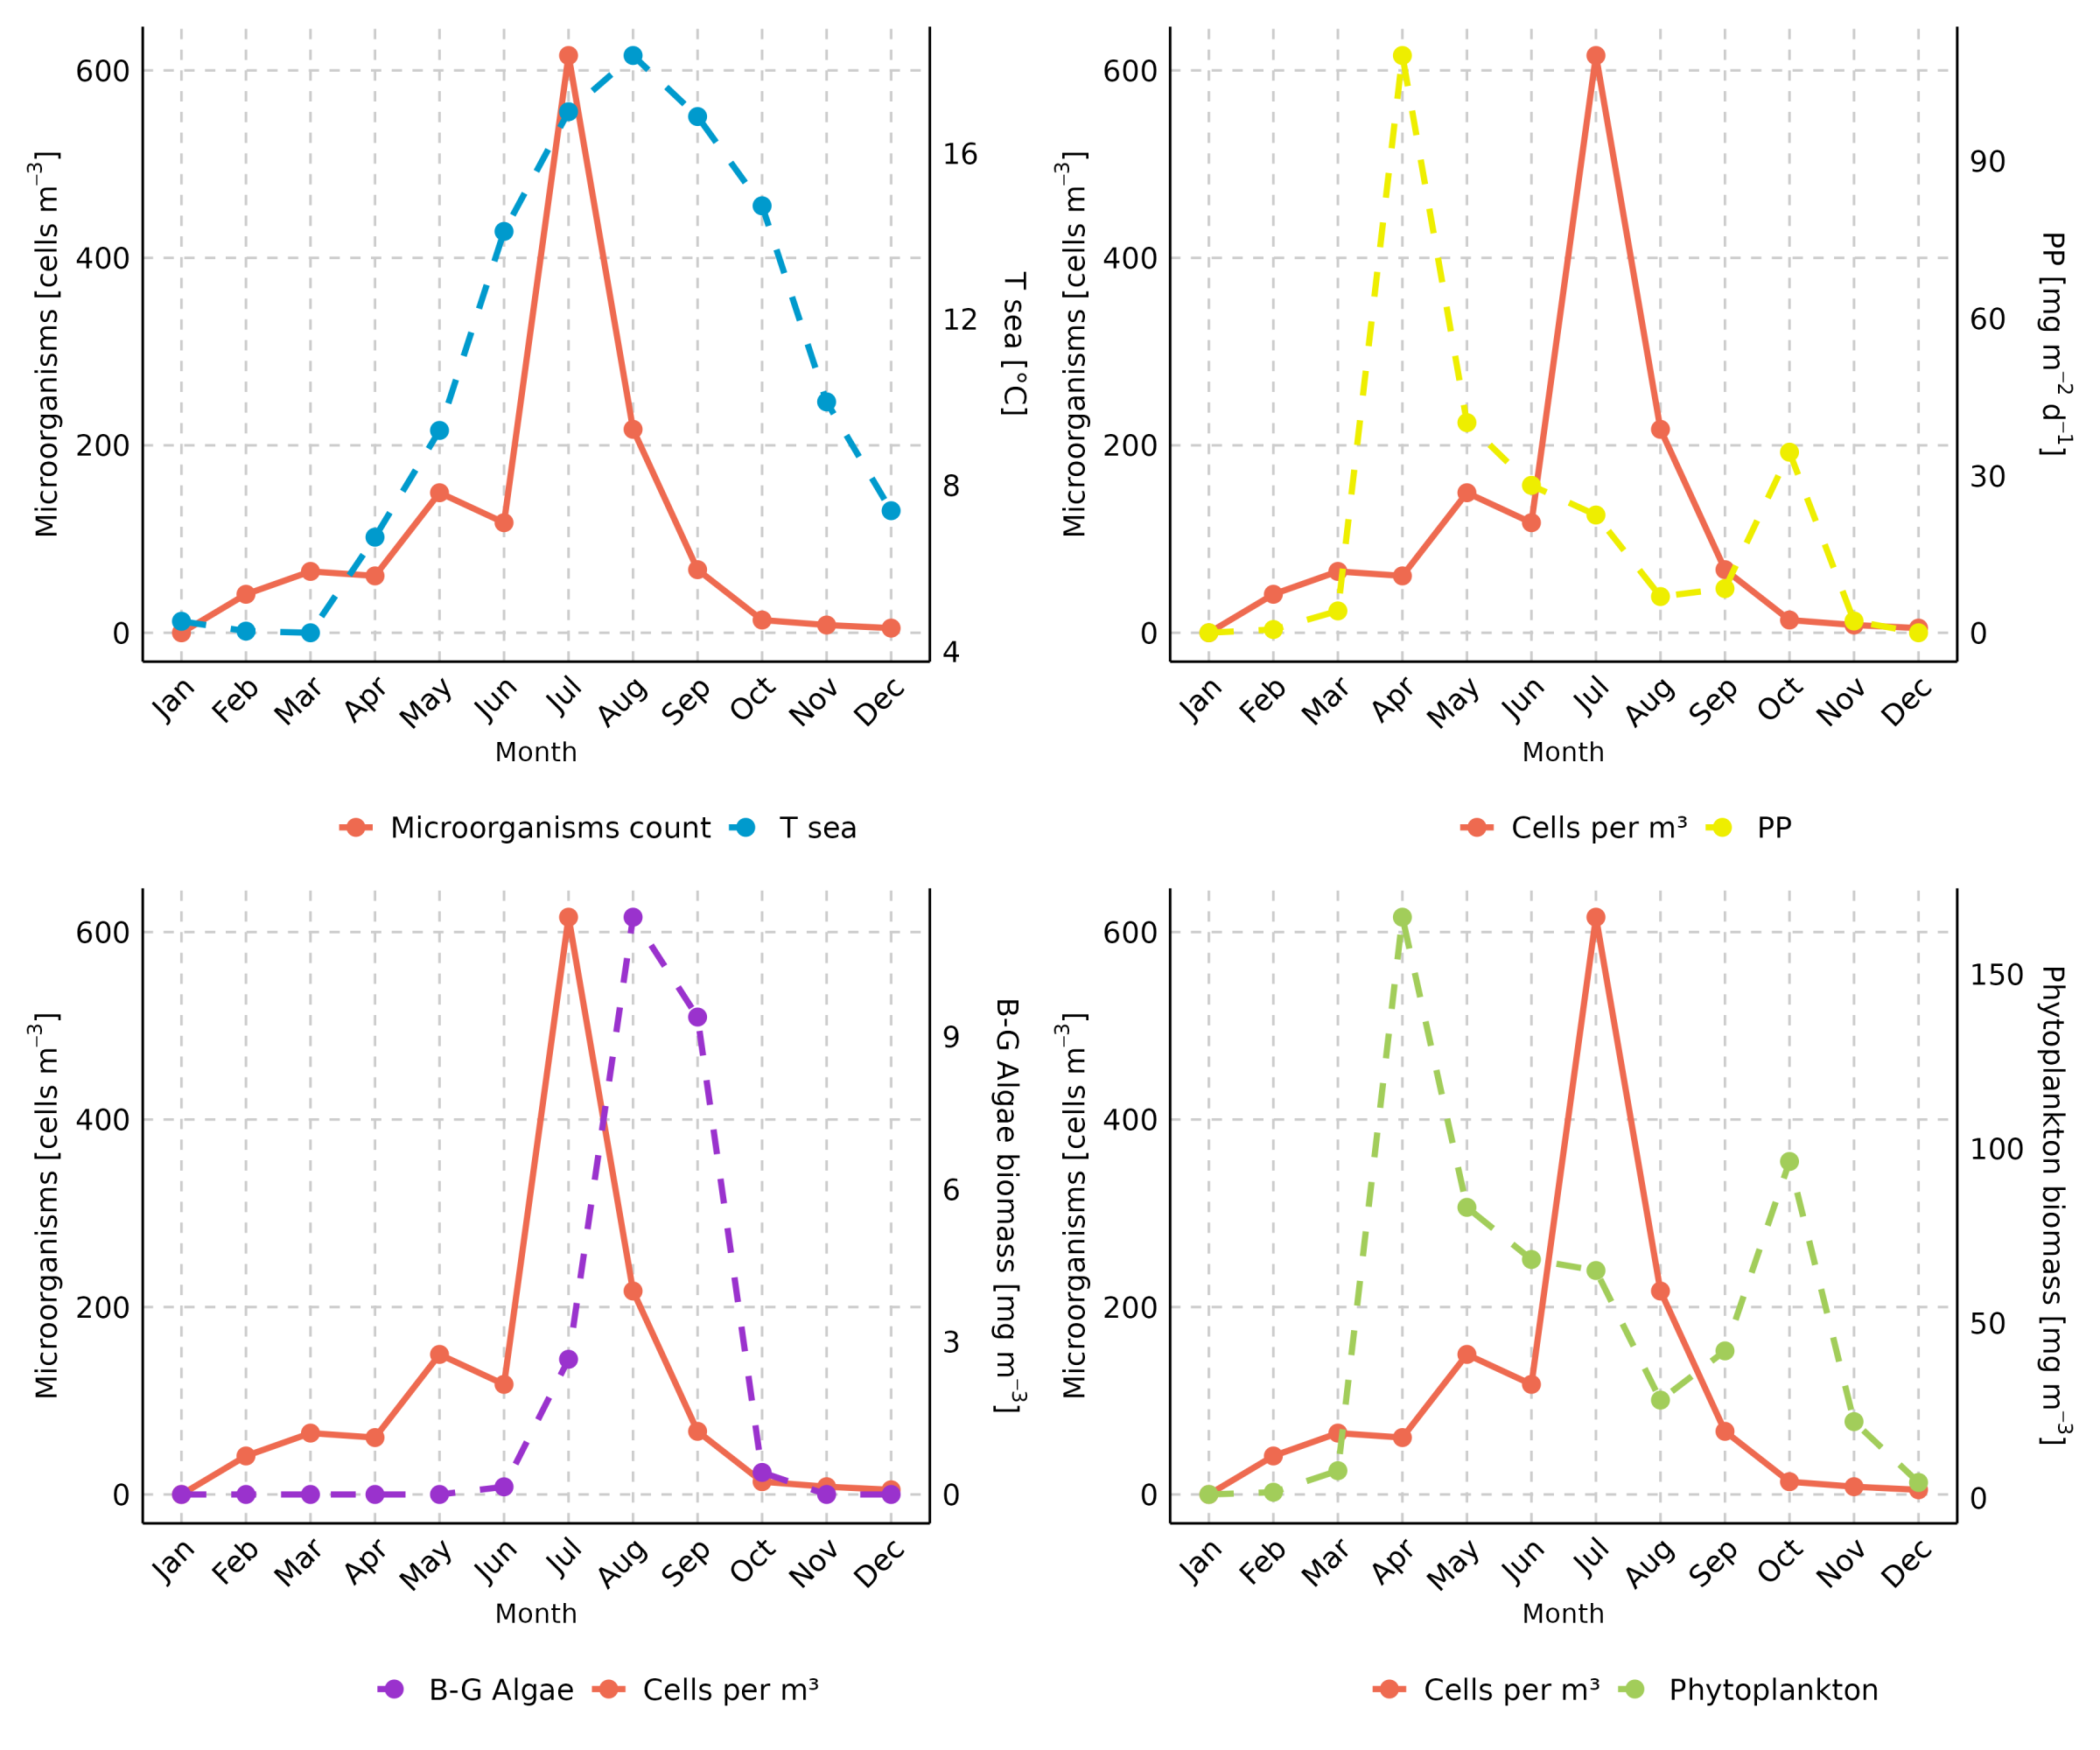

**Fig.** 2: Monthly variation of cells number of airborne microalgae and cyanobacteria and sea parameters. T sea [ºC] – sea temperature, PP [mg m-2 d-1] – primary production, B-G Algae [mg m-3] – cyanobacteria concentration in the sea, and phytoplankton biomass [mg m-3].

Scientific research confirms that global warming in the case of the Baltic Sea appears to affect primary production in several interlinked ways27. On one hand, warming extends the phytoplankton growing season; on the other hand, warming-induced changes in stratification and nutrient dynamics may favor summer cyanobacterial blooms27. Consequently, an increase in the abundance of cyanobacteria in the atmosphere can also be expected.

Moreover, studies conducted both in the Baltic Sea region and in other parts of the world have confirmed that the taxonomic composition of cyanobacteria and microalgae undergoes seasonal variations [**10**;12]. These changes are not limited to fluctuations in the number of recorded taxa but also encompass shifts in their relative abundance throughout the year. Therefore, it is difficult to clearly determine which division dominates in a given climate zone. The dominance of individual groups does not have to be a constant phenomenon (Fig. 1). This may result from various sources of bioaerosols, such as water bodies or terrestrial environments, as well as changing meteorological factors. Therefore, detecting such patterns requires at least several years of sampling. Thus, it remains valid that, regardless of location, Cyanobacteria are consistently detected in the atmosphere worldwide4.

The number of cyanobacteria and microalgae cells in the atmosphere over southern Baltic Sea was determined only during the studies conducted in 20204, with the number of cyanobacteria and microalgae ranging from zero to 1685 cells m-3. A review by Després et al.2 states that the concentration of microalgae and cyanobacteria in the air varies between 100 and 1000 cells m−3 that is consistent with presented results. While Reisser28 reported the presence of 300-500 cells m-3 of microalgae and cyanobacteria that we inhale on sunny summer days. In 2020, the highest average number of taxa recorded in the air occurs in July and then decreases (Fig. 1). We showed that in the atmosphere of study area, airborne cyanobacteria or green algae alternately dominate, and they can also be expected in the winter months. Additionally, cyanobacteria dominate in August, which is closely related to the occurrence of toxic cyanobacterial blooms in the southern Baltic Sea area12 (Fig. 2).

In the coastal zone of the southern Baltic Sea during the winter period, only cyanobacteria and green algae were detected, with no significant dominance of any of this group (Fig. 1b). Moreover, during examined period of winter, the number of airborne microorganisms was relatively low. For instance, in January 2020, only 2 taxa were recorded, and the average number of cells was equaled to 3.47 cells m−3, while in February the number of cells increased up to 41 cells m−3 on average.

With regional projections indicating that the annual mean near-surface temperature in the Baltic Sea region could rise by 1.4°C to 3.9°C by the end of this century compared to 1976–200529, it is anticipated that taxa typically associated with spring may increasingly be recorded during the winter months. Conversely, rising winter temperatures may enhance the appeal of the region for tourism, even during the winter season. However, the ongoing increase in temperatures that favors more frequent cyanobacterial blooms may extend human exposure to these organisms and their toxins beyond the summer months. Similar to the case of pollen, the extension of the growing season due to climate change may lead to prolonged exposure to airborne cyanobacteria and microalgae30. This could increase sensitization and exacerbate the prevalence and severity of symptoms associated with respiratory conditions, as has been observed with seasonal allergic diseases31.

## Meteorological factors vs. the amount of cyanobacteria and microalgae in the air

Meteorological parameters impact the abundance and taxonomic diversity of cyanobacteria and microalgae in atmospheric aerosols throughout the coastal zone of the Baltic Sea12,26. The primary meteorological factors include air temperature and, humidity, wind speed and direction, air mass advection, precipitation, and the duration of available light (photoperiod). Depending on the prevailing weather conditions, cyanobacteria and microalgae may be released into the atmosphere from water bodies or remitted from various surfaces [11; **10**;32]. This process is most efficient during periods of high primary productivity12,26. Certain meteorological factors can facilitate the transport of these microorganisms across land or contribute to their removal from the atmosphere4,7,12,26,33,34.

The findings from our studies suggest that an increase in air temperature can stimulate the presence of cyanobacteria and microalgae in the atmosphere, analogous to its effect on enhancing phytoplankton biomass in the sea. In the coastal zone of the southern Baltic Sea, a strong positive proportional relationship (Spearman rank correlation coefficient 0.755, *p* < 0.001) has been observed between the quantity of airborne cyanobacteria and microalgae and air temperature12 (Fig. 3). This relationship appears robust enough that it remains unaffected by benzo(a)pyrene, an indicator of air pollution with polycyclic aromatic hydrocarbons (PAHs)34.

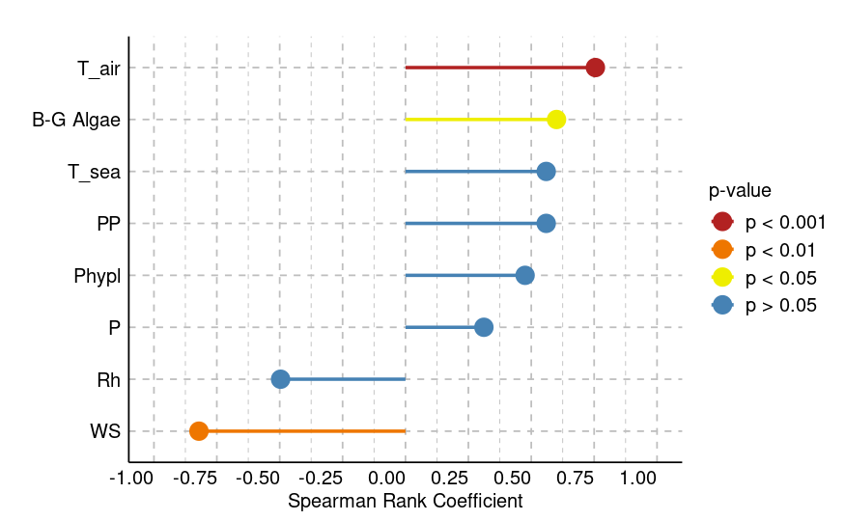

**Fig.** 3: Spearman’s rank correlation coefficients and their statistical significance between the number of cyanobacteria and microalgae cells and environmental parameters, including air temperature (T_air), cyanobacteria biomass in the sea (B-G Algae), sea temperature (T_sea), primary production (PP), phytoplankton biomass (Phypl) atmospheric pressure (P), relative humidity (Rh), and wind speed.

Wind speed is a crucial meteorological factor influencing both the abundance and taxonomic diversity of cyanobacteria and microalgae in the atmosphere, as observed globally and specifically also in the Baltic Sea region4,7,12,26 (Fig. 3). Wind facilitates the drying, fragmentation, and airborne transport of algae. Generally, the impact of wind is similar for both bioaerosols and other particulate matter in the air. Higher wind speeds enhance the production of bioaerosols and enable their transport over greater distances [**35**;7].

Rough water surfaces generate three types of droplets—spume drops, film drops, and jet drops—that contribute to bioaerosol emission. It is proposed that spume drops are efficiently dislodged from waves when wind speeds exceed 7.0 to 11.0 m s−136. Research carried out in the coastal zone of the Baltic Sea has showed that typically decreasing of wind speed is linked to higher concentrations of cyanobacteria and microalgae12,26. The results showed that for higher concentrations of airborne cyanobacteria and microalgae ideal is wind speed between 2.3 and 2.7 m s−1. These low wind speed correlated annually with the phytoplankton bloom season in the Baltic Sea. Wind speed was higher in the winter, averaging 5.8 m s−1. On the other hand, after several days of high air temperatures (over 30°C), a notable rise in phytoplankton concentration in the seawater during the growing season was noted under the low wind speed (averaging 1.3 m s−1)12. The decrease of airborne microalgae and cyanobacteria with the wind speed increase was conﬁrmed by a Spearman rank correlation coefficient -0.825; *p* < 0.00112 (Fig. 3). Interestingly, studies conducted in Bratislava15 also indicate that the abundance of cyanobacteria and microalgae is dependent on wind speed. However, in this region, a strong positive correlation has been observed, suggesting that an increase in wind speed leads to a higher concentration of cells in the atmosphere15. The differences in results obtained in Bratislava, which is located on the Danube River15, and the Baltic Sea coast highlight the significant influence of the study location and, consequently, the sources of cell origin. Differences in the impact of wind may result from distinct sources of bioaerosols in the two locations. When the source of bioaerosols is unrelated to marine blooms, wind acts as a factor facilitating the transport of particles, leading to a positive correlation. However, if these particles originate from waterbody blooms, which typically occur under conditions of high temperature and low wind speed, wind negatively affects the abundance of cyanobacteria and microalgae in the atmosphere.

Elevated air temperature along with almost calm wind conditions and no strong waves probably encouraged phytoplankton blooms in the surface waters, which in turn led to a rise in cyanobacteria and microalgae abundance in the air. This shows that air temperature and wind speed are closely related factors that have a big impact on microorganisms emission efficiency. The presence of biaerosols in the atmosphere depends on how these two factors interact. Eventually, airborne microbes may become part of clouds, where they may be deposited either wet or dry4,7,37,38. According to Marshall and Chalmers37 air humidity is a significant meteorological factor that influences the release of microalgae and cyanobacteria into the atmosphere. Desiccation may increase the possibility of algae taking into the air, according to the authors’ findings. When compared to other meteorological parameters, our findings showed that relative humidity alone weakly affects the prevalence of cyanobacteria and microalgae in the air (Spearman rank coefficient -0.496, *p* < 0.05) (Fig. 3). A negative weak relationship was noted also by Žilka et al.15 with Spearman rank coefficient equal to -0.305 (*p* < 0.001). The differences in the influence of meteorological parameters between Bratislava and Gdynia are primarily driven by their distinct climatic conditions—Gdynia, as a coastal city, is continuously influenced by humid air masses from the Baltic Sea, whereas Bratislava, located inland, experiences a more continental climate with greater fluctuations in temperature and humidity of air.

The significant correlation which we found in our measurements was that rainfall had a reduced ability to remove cyanobacteria and microalgae when relative humidity rose during the day26. The study’s findings showed that, of all the meteorological parameters, rainfall seems to have the greatest impact on the quantity of cyanobacteria and microalgae in the air above the coastal zone of the Baltic Sea26. There are two main ways that rainfall impacts these microorganisms’ existence. First, microalgae and cyanobacteria can be successfully removed from the atmosphere by rainfall. Our previous results demonstrated that, in comparison to their pre-rainfall values, the quantity of cyanobacteria and microalgae cells in aerosols decreased by 21–87% after each rainfall event26. This decrease is noteworthy, particularly considering the roughly 40% drop in atmospheric bacteria that was noted during washout procedures [Ouyang et al., 2020]. Rainfall, however, has the opposite effect of increasing the taxonomic variety of algae on land and in the ocean. Raindrops can remove microalgae and cyanobacteria from clouds and terrestrial object surfaces such as tree leaves14,39. Furthermore, rainfall may encourage the re-emission of microalgae and cyanobacteria that have already been emitted into the atmosphere26,40. Research carried out in the coastline zone of the southern Baltic Sea revealed that there can be differences in the taxonomic composition of microalgae and cyanobacteria in the atmosphere between before and after rainfall. However, brief rainstorm events did not fully eliminate any one taxon from the atmosphere. *Synechococcus* sp. was an exception to this rule, completely wiped-out during rainstorm episodes that lasted longer than twenty-four hours. Furthermore, it was discovered that some taxa, including *Nodularia* cf. *harveyana*, that were not discovered in aerosols prior to the rain may be present in the downpour26.

This fluctuation may be linked to the nearly daily variations in the air mass trajectories’ directions, which facilitate the introduction of additional microorganism species from marginally distinct source locations. Additional research has shown that alterations in the air mass passing over the measuring station can be linked to the occurrence of fresh microalgae in samples7,8,26. One of the most important meteorological factors impacting the quantity and taxonomic diversity of cyanobacteria and microalgae in the air above the coastal zone is the direction of air mass advection, coupled with wind speed. Long-distance microbe transportation is caused by this factor7,8. For example, backward trajectories of air masses confirmed that *Gloeothece* sp., observed in the atmosphere over Gdynia in 2015, was transported with air masses from the Arkona Basin7. Furthermore, the transport of particles is also influenced by their size, with smaller particles being more efficiently carried over longer distances7. This fact highlights the significant role of aerosol size in determining the atmospheric presence of cyanobacteria and microalgae.

## Cyanobacteria and microalgae suspended in the air can pose a potential threat to human health

Air quality is now acknowledged as one of the most critical environmental threats, impacting animals, and human health. The presence of chemical substances in the atmosphere has been a major focus of scientific research for the last two decades. Significant research efforts have been dedicated to this issue, as detailed by Manisalidis et al.41. The problem of air pollution caused by particulate matter of various sizes (PMx) and polycyclic aromatic hydrocarbons (PAHs) has been extensively documented in the southern Baltic Sea region42–45. In addition to chemical pollutants, bioaerosols—which include bacteria, viruses, fungi, pollen, cyanobacteria, and microalgae—can also negatively impact human health [46;47;4;48; **Dales et al., 2025b**]. However, there still is limited information available regarding the presence of cyanobacteria and microalgae in the atmosphere in comparison to other particles.

Genitsaris et al.3 created a list of cyanobacteria and microalgae found in the atmosphere that might be harmful to humans if breathed. 29 species of airborne cyanobacteria and microalgae were discovered in 2020 during study in the Baltic Sea coastal zone12. Among these, several taxa—including *Amphora* sp., *Bracteacoccus* sp., *Chlorococcum* sp., *Chlorosarcinopsis* sp., *Oocystis* sp., *Stichococcus* sp., *Nodularia* sp., *Nostoc* sp., *Synechocystis* sp., *Chrysochromulina* sp., and *Gymnodinium* sp. were identified as potentially harmful to human health when inhaled12. When these organisms penetrate the human respiratory system with aerosols, they can lead to a variety of symptoms, including headaches, nausea, dizziness, allergic responses, exacerbations of asthma, skin rashes, eye irritation and redness, and neurotoxic effects (Fig. 4). They can also produce toxins, as confirmed by studies conducted in the coastal zone of the southern Baltic Sea12. Currently, there is no scientifically established data on the quantity of toxins that must be inhaled to cause adverse health effects in humans. However, there are studies that confirm that the presence microalgae in the atmosphere negatively affects the function of human lungs16.

Some researchers have confirmed that microcystin-LR (MC-LR) can have toxic effects on organisms even at lower doses when inhaled49. Due to this, MC-LR was selected as the indicator toxin. MC-LR, a well-known hepatotoxin, is one of the most studied toxins produced by cyanobacteria. MC-LR are known not only to damage liver function but also to promote the formation of liver tumors and induce cell death in hepatocytes through apoptosis and necrosis50. In our study, the concentrations of MC-LR varied from levels below the detection threshold up to 420 fg cell−1;12. Various cyanobacterial strains, including *Nostoc* sp., *Nostoc edaphicum*, *Pseudanabaena galeata*, *Pseudanabaena catenata*, *Leptolyngbya* sp., *Synechococcus* sp., *Gloeocapsa* sp., and *Rivularia* sp. were found to contain MC-LR. The peak concentration of this toxin (420 fg cell−1) was observed noted in the picocyanobacterium *Synechococcus* sp.12. It is notable that *Synechococcus* sp. is one of the most ubiquitous photoautotrophic microorganisms on Earth51. Nevertheless, it’s crucial to emphasize that various species or strains within the same genus might have differing toxin production levels12. Generally, during algal blooms, there is an increased chance of breathing in hazardous organisms and their poisons4,12. According to our research, May 2020 was the month with the greatest MC-LR concentrations12. On the other hand, aerosols from a major cyanobacteria bloom in the coastal zone of the southern Baltic Sea in August 2020 revealed the presence of *Nodularia* sp., a cyanobacterium that is known to pose health risks. Toxic cyanobacteria blooms and nodularin production typically take place in the summertime in the measuring region52,53. The amount of MC-LR in the atmosphere was found to be lower in August than it was in May, although it was still present in species from the genus *Synechococcus*, *Chroococcus*, *Nodularia*, *Phormidium*, and *Pseudanabaena*. As a result, it is advised that sensitive people, including those with asthma or inhalant allergies, people stay out of the Baltic Sea’s coastline zone for as long as possible when there are strong algal blooms.

The relationship between bioaerosols’ size and deposition in the human respiratory system is another important topic to scientific research. Smaller bioaerosols are predicted to enter the human respiratory system more deeply than particulate matter (PMx) and to settle in the bronchial and acinar airways, where they will cause a variety of diseases7,46,54. To quantitatively assess the presence of airborne algae and cyanobacteria, a six-cascade impactor was employed as a surrogate for the human respiratory tract4. It could gather particles in six size ranges (> 7 μm, 4.7–7 μm, 3.3–4.7 μm, 2.1–3.3 μm, 1.1–2.1 μm, and ≤1.1 μm) with the proper diameter. Studies carried out in the coastal zone of the Baltic Sea revealed that, of all the coarse particles (> 2.1 μm) present in bioaerosols, the total number of cyanobacteria and microalgae cells was the largest, accounting for 61% of all the cells (6901 cells m−3). This size of particle can be found in the upper respiratory system, although it can only get as far as the secondary bronchi. Aside from the previously mentioned, an effort was undertaken to pinpoint taxonomic groupings in various particle diameter ranges that may be harmful to human health3. Throughout the investigation, it was noted that roughly 30.0% of the pathogenic microorganisms found in aerosols — *Amphora* sp., *Bracteacoccus* sp., *Chlorococcum* sp., *Chlorosarcinopsis* sp., *Oocystis* sp., *Stichococcus* sp., *Nodularia* sp., *Nostoc* sp., *Synechocystis* sp., *Chrysochromulina* sp., and *Gymnodinium* sp. were found in particles small enough to enter secondary bronchi (< 2.1 μm).

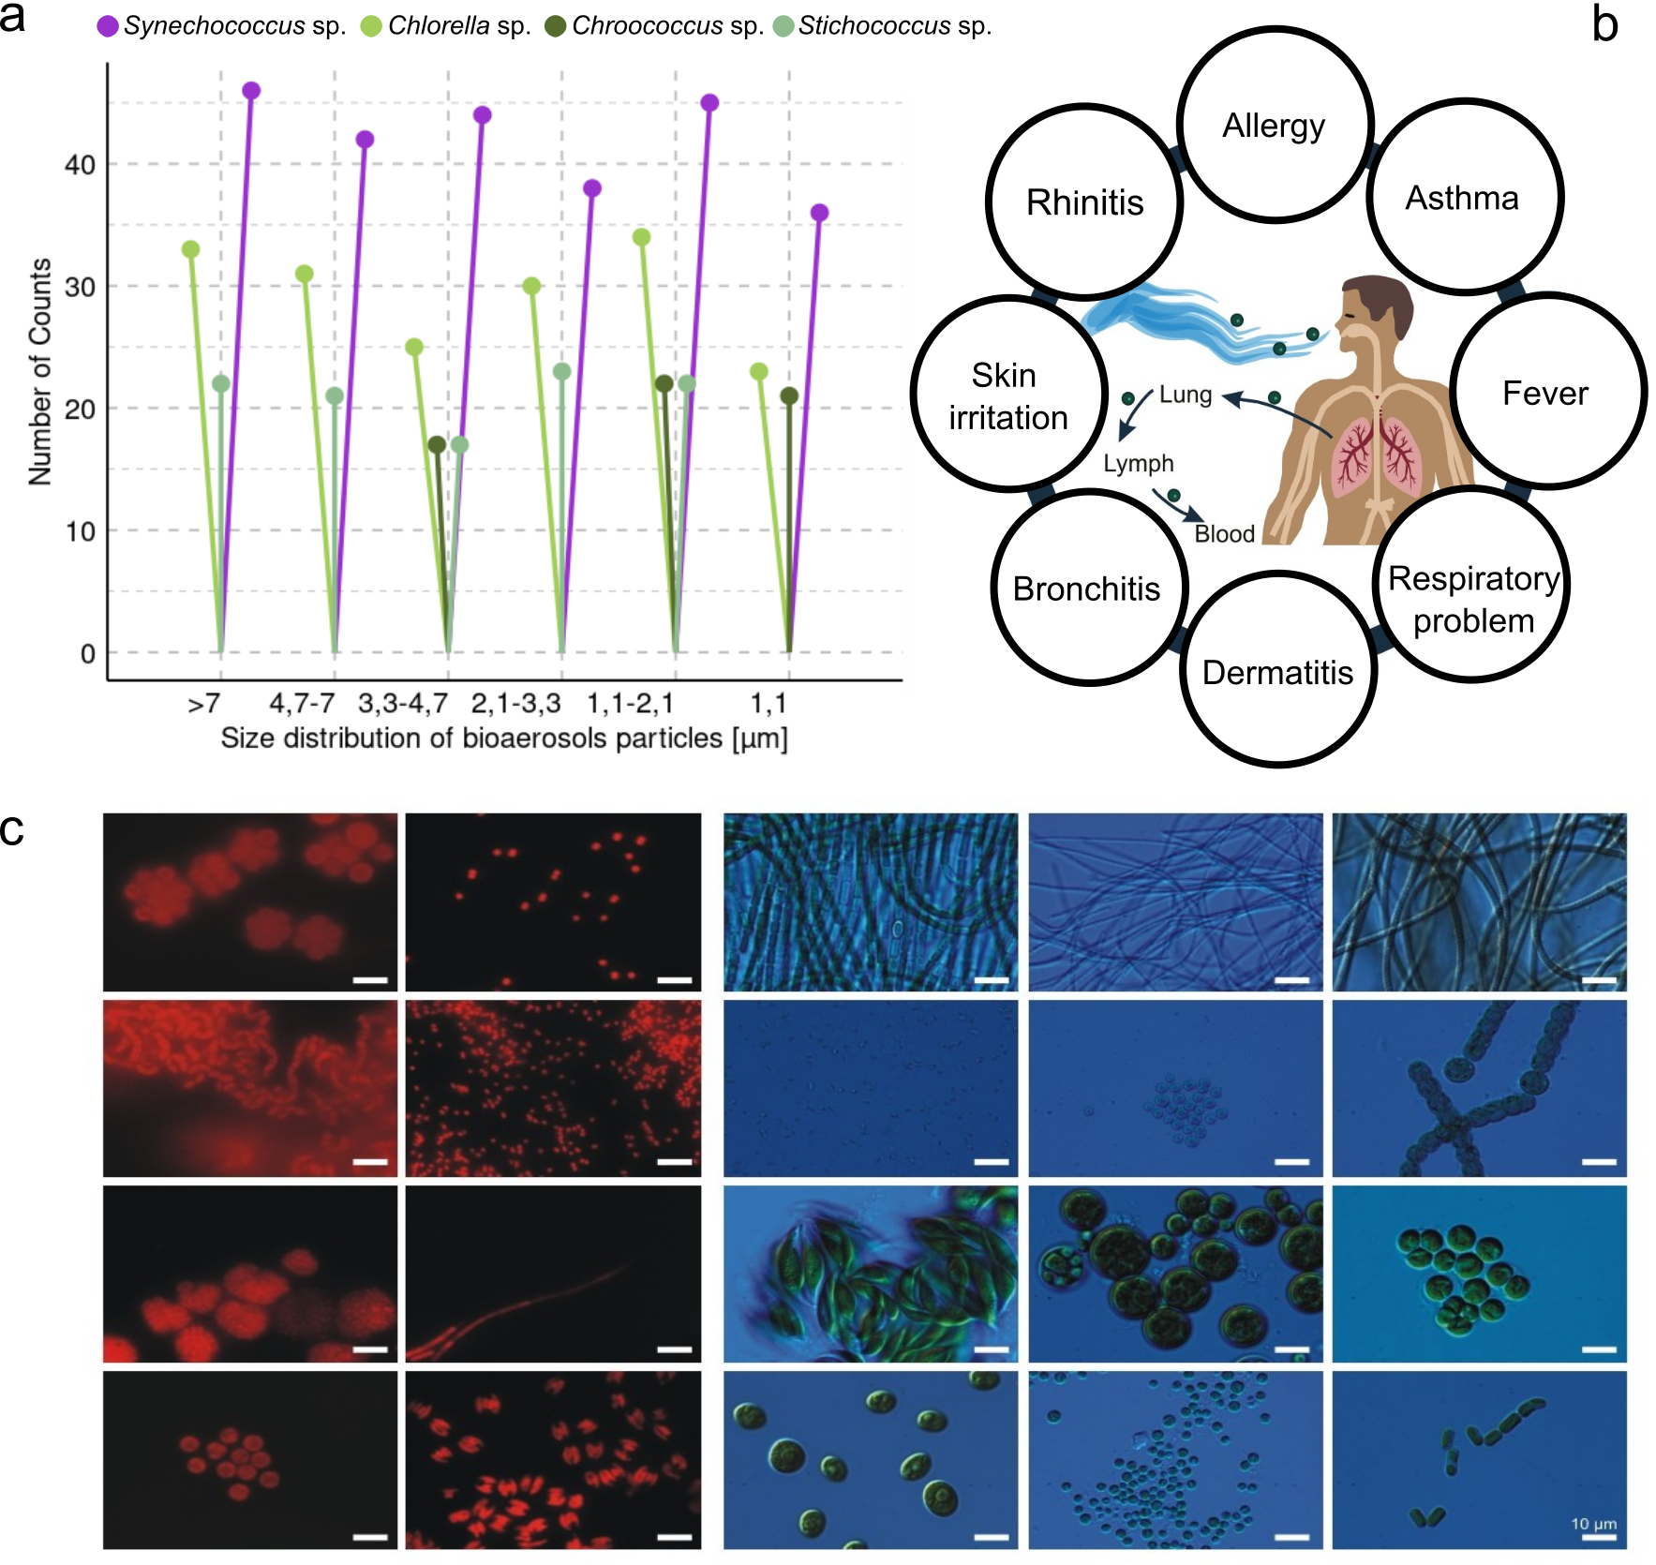

**Fig.** 4: Airborne cyanobacteria and algae affecting human health. a The occurrence of selected airborne cyanobacteria and microalgae in different cell size classes. b The most frequently recorded species of airborne cyanobacteria and microalgae from the air. c Effects of the penetration of airborne cyanobacteria and microalgae of various sizes into the human body.

The most hazardous taxa were found in coarser particles, which don’t get to the deeper reaches of the respiratory system. The number of microalgae and cyanobacteria, however, did not change statistically significantly based on the size distribution of the bioaerosol (Kruskal Wallis test, *p* > 0.05). This suggests that individual organisms cannot be assigned to a single size fraction.

The cause of this might be because the diameter of the coccoid algae varies from a few to several dozen μm, affecting the size of organisms that fit through the impactor nozzles at a particular diameter. When it comes to filamentous organisms, the problem becomes more intricate because their length and breadth vary from a few to several μm. Consequently, a shorter plane-arranged organism can enter nozzles with a smaller diameter and land deeper into the human respiratory system. Therefore, it should be taken into consideration that these organisms can enter human alveoli in the event of substantial emissions of poisonous cyanobacteria and microalgae, such as during hazardous cyanobacterial blooms12. This is confirmed by studies conducted by Dey et al. using the Multiple-Path Particle Deposition Model (MPPD). These studies precisely indicate the regions of the human respiratory system where particles are deposited. The results showed that during the summer period in the Baltic Sea region, the highest mass deposition fraction of cyanobacteria and microalgae was found in particles with aerodynamic diameters ranging from 2.1 to 3.3 µm. The lungs’ right lower lobe had the highest mass deposition fraction, followed by the right upper, left lower, right middle, and left upper lobes. Bioaerosols having a diameter between 2.1 and 3.3 µm had the highest lobar deposition.

Moreover, studies on avian influenza, measles, and SARS (including COVID-19) have highlighted that viruses and bacteria can pose a greater health risk when present in polluted air55–61. It is crucial to explore the potential impact of cyanobacteria and microalgae in these contexts34. The threat to human health is greater the more toxic and dangerous compounds there are in the air. Such chemical compounds include benzo(a)pyrene, commonly recognized as a significant air pollutant in many parts of the world, including the southern Baltic Sea. Because of its carcinogenic, mutagenic, and poisonous qualities, this chemical is particularly dangerous62. Benzo(a)pyrene is classified as a Group 1 carcinogen by the International Agency for Research on Cancer (IARC), signifying a high potential for human cancer. The allowable yearly average concentration of this chemical in PM10 has been determined by the European Union at 1 ng m−3 (Directive 2004/107/EC). The Gdynia region has one of the lowest levels of benzo(a)pyrene pollution in Poland, but even in aerosols with the smallest diameter, the daily concentration of this pollution surpasses the annual standard several times a year42,44. In our previous studies we focused on the relationship between human health and benzo(a)pyrene in the air and cyanobacteria and microalgae34. In a laboratory experiment different concentrations of benzo(a)pyrene were applied to selected strains of cyanobacteria and microalgae that were isolated from the atmosphere. The concentrations ranged from relatively low (standard solution of 7.8 ng L−1, equivalent to 0.5 ng m−3 in the air) to very high (standard solution of 624 ng L−1, equivalent to 40 ng m−3 in the air). g m−3 in the atmosphere) to extremely high concentrations (standard solution of 624 ng L−1, or 40 ng m−3 in the atmosphere). It’s interesting to note that none of the strains were destroyed by the addition B(a)P, which is extremely harmful to humans34. Moreover, several cyanobacteria and microalgae exhibited changes in the quantity of assimilatory pigments, a rise in cell population, and the ability to perform photosynthesis upon the addition of even low concentrations of B(a)P. Thus, benzo(a)pyrene-induced air pollution, even at low concentrations, is expected to promote the proliferation of airborne cyanobacteria and microalgae. We also aimed to determining if cyanobacteria and microalgae could break down the benzo(a)pyrene already present in the air. When comparing the concentration of benzo(a)pyrene in the presence of green algae to cyanobacteria and diatoms, it was observed that there was a notable variation at the conclusion of the experiment34. The potential for cyanobacteria and diatoms to degrade benzo(a)pyrene remains an area requiring further research. However, our results indicate green algae can degrade even up to 80% of benzo(a)pyrene. This finding aligns with existing scientific literature63,64.

However, it is worth noting that while in the case of many bioaerosols there are studies indicating the relationship between biological particles and air pollution, in the case of cyanobacteria and microalgae such studies are still lacking. However, Žilka et al.15 in Slovakia demonstrated significant negative dependency between the concentration of bioaerosols, such as microalgae and cyanobacteria, and air pollution concentration, particularly CO, NO2, and PM10. High concentrations of carbon monoxide can inhibit the growth of source algae, while elevated nitrate levels may restrict the development of cyanobacteria. At the same time, tropospheric ozone generally shows positive correlations with the concentration of airborne microorganisms, suggesting that it may contribute to their presence. A particularly important observation is that the simultaneous increase in the concentration of microorganisms and ozone may exacerbate symptoms of respiratory allergies in urban areas15.

This raises the question of whether the concentration of benzo(a)pyrene in the air in coastal areas such as northern Poland is significantly reduced compared to other regions of Central Europe due to the presence of green algae. Would the absence of green algae result in higher concentrations of this hazardous chemical compound? Future research should focus on identifying the byproducts formed when benzo(a)pyrene is decomposed by green algae. While the removal of benzo(a)pyrene from the environment might seem beneficial, the decomposition process could yield potentially harmful substances, such as peroxides, quinones, sulfur, and nitric derivatives, which might still pose risks to living organisms65,66. Despite these concerns, airborne green algae offer a promising avenue for bioremediation.

## The future of airborne microalgae and cyanobacteria research in the era of machine learning

Conducting numerous studies on cyanobacteria and microalgae by our team over the past few years has led to many conclusions and future recommendations. Based on the data obtained and numerous interdisciplinary observations, the authors have determined how the collected data can be used to expand the existing state of knowledge using modern machine learning techniques. By identifying the gaps in these studies, many recommendations for future applications of machine learning research can be made. One of the biggest problems concerning the research on cyanobacteria and microalgae is the non-ergonomic techniques for determining the quantity and taxonomic composition of microorganisms4. A significant improvement in these studies would be conducting such analyses online using automatic bioaerosols sensors67,68. Automatic monitors are increasingly being utilized in research, primarily for the analysis of atmospheric pollen. However, efforts are also being made to extend these methods to the study of fungi67. Current technologies employing holographic imaging of bioaerosols, combined with particle fluorescence analysis, demonstrate potential for application in the investigation of airborne cyanobacteria and microalgae69. Picoplanktonic cyanobacteria, for example, can reach sizes as small as approximately 0.2–2 µm, whereas the Swisens Poleno is primarily designed for larger particles but operates effectively from 2 µm onward.

However, to train the system to recognize specific particles, it is essential to have well-characterized particle banks. These reference libraries consist of known bioaerosol samples, including pollen, fungal spores, cyanobacteria, and microalgae, which serve as training data for the machine learning algorithms. Without such databases, the system would lack the necessary information to accurately classify airborne particles based on their holographic images and fluorescence spectra. Establishing comprehensive particle banks is therefore a crucial step in enhancing the accuracy and reliability of automated bioaerosol monitoring. The more accurately the taxonomic composition is determined, the better the accuracy, so it would be advisable to conduct genetic studies.

# Conclusion

This study reveals differences in the impact of meteorological parameters based on the geographical location. In addition to air temperature and wind speed, the prevalence of cyanobacteria and microalgae in the coastal zone is significantly influenced by factors directly related to the sea, including primary production and phytoplankton biomass. The taxonomical composition of cyanobacteria and microalgae in the atmosphere can vary considerably between years, which is a natural phenomenon also observed in the marine environment.

Ongoing climate change, which has a profound impact on the sea, will probably inevitably affect the composition and abundance of microorganisms in the atmosphere in the future. If, as predicted, the Baltic Sea experiences more intense summer blooms of toxic cyanobacteria due to climate change, an increased presence of these organisms in the air should also be expected. Additionally, the ongoing in the last decade temperature increase in the winter period contribute to the year-round presence of these organisms in the atmosphere.

Moreover, in the atmosphere over the coastal zone of the Gulf of Gdansk microorganisms classified as dangerous to human health as well as those which can produce toxins have been recorded. Part of them occur in particles of the small size (<2.1 µm in diameter) what make it possible their transport into the deepest parts of the human respiratory system. The picoplanktonic cyanobacterium *Synechococcus* sp. exhibits a high capacity for toxin production and is detected even in the smallest particle fractions, rendering it particularly hazardous and warranting targeted monitoring. Between analysed taxa, the green algae species demonstrated the highest potential for B(a)P degradation, thereby suggesting a promising avenue for bioremediation. At low levels of benzo(a)pyrene concentrations cyanobacteria and microalgae can have considerable implications for the advancement of biotechnology. On the other hand, we lack knowledge about the substances into which compounds degraded by green algae break down and whether these degradation products might pose a greater risk to health than the original compound.

# Data availability

Data supporting this study is available on: <https://github.com/FundyPhytoPhys/SynBaltic> (public GitHub Repository).

Code to perform data processing and analyses is available at <https://github.com/FundyPhytoPhys/SynBaltic>.

# CRediT authorship contribution statement

# Declaration of Competing Interest

The authors declare that they have no known competing financial interests or personal relationships that could have appeared to influence the work reported in this paper.

# Acknowledgements

# References

1. Urbano, R., Palenik, B., Gaston, C. J. & Prather, K. A. [Detection and phylogenetic analysis of coastal bioaerosols using culture dependent and independent techniques](https://doi.org/10.5194/bg-8-301-2011). *Biogeosciences* **8**, 301–309 (2011).

2. Després, V. R. *et al.* [Primary biological aerosol particles in the atmosphere: A review](https://doi.org/10.3402/tellusb.v64i0.15598). *Tellus B: Chemical and Physical Meteorology* **64**, 15598 (2012).

3. Genitsaris, S., Kormas, K. A. & Moustaka-Gouni, M. Airborne algae and cyanobacteria: Occurrence and related health effects. *Front. Biosci* **3**, 772–787 (2011).

4. Wiśniewska, K., Lewandowska, A. U. & Śliwińska-Wilczewska, S. [The importance of cyanobacteria and microalgae present in aerosols to human health and the environment – Review study](https://doi.org/10.1016/j.envint.2019.104964). *Environment International* **131**, 104964 (2019).

5. Sun, Y.-F. *et al.* [Will ‘Air Eutrophication’ Increase the Risk of Ecological Threat to Public Health?](https://doi.org/10.1021/acs.est.3c01368) *Environmental Science & Technology* **57**, 10512–10520 (2023).

6. El-Gamal, A. D. Aerophytic Cyanophyceae (cyanobacteria) from some Cairo districts, Egypt. *Pak. J. Biol. Sci* **11**, 1293–1302 (2008).

7. Lewandowska, A. U., Śliwińska-Wilczewska, S. & Woźniczka, D. [Identification of cyanobacteria and microalgae in aerosols of various sizes in the air over the Southern Baltic Sea](https://doi.org/10.1016/j.marpolbul.2017.07.064). *Marine Pollution Bulletin* **125**, 30–38 (2017).

8. Wiśniewska, K. A., Śliwińska-Wilczewska, S. & Lewandowska, A. U. [The first characterization of airborne cyanobacteria and microalgae in the Adriatic Sea region](https://doi.org/10.1371/journal.pone.0238808). *PLOS ONE* **15**, e0238808 (2020).

9. Carson, J. L. & Brown Jr, R. M. The correlation of soil algae, airborne algae, and fern spores with meteorological conditions on the Island of Hawaii. (1976).

10. Sharma, N. K., Rai, A. K. & Singh, S. [Meteorological factors affecting the diversity of airborne algae in an urban atmosphere](https://doi.org/10.1111/j.2006.0906-7590.04554.x). *Ecography* **29**, 766–772 (2006).

11. Rosas, I., Roy-Ocotla, G. & Mosiño, P. [Meteorological effects on variation of airborne algae in Mexico](https://doi.org/10.1007/BF01084602). *International Journal of Biometeorology* **33**, 173–179 (1989).

12. Wiśniewska, K., Śliwińska-Wilczewska, S., Savoie, M. & Lewandowska, A. U. [Quantitative and qualitative variability of airborne cyanobacteria and microalgae and their toxins in the coastal zone of the Baltic Sea](https://doi.org/10.1016/j.scitotenv.2022.154152). *Science of The Total Environment* **826**, 154152 (2022).

13. Guiry, M. D. & Guiry, G. M. AlgaeBase. World-wide electronic publication, National University of Ireland, Galway. 2017. (2017).

14. Dillon, K. P. *et al.* [Cyanobacteria and Algae in Clouds and Rain in the Area of puy de Dôme, Central France](https://doi.org/10.1128/AEM.01850-20). *Applied and Environmental Microbiology* **87**, e01850–20 (2020).

15. Žilka, M., Tropeková, M., Zahradníková, E., Kováčik, Ľ. & Ščevková, J. [Temporal variation in the spectrum and concentration of airborne microalgae and cyanobacteria in the urban environments of inland temperate climate](https://doi.org/10.1007/s11356-023-29341-8). *Environmental Science and Pollution Research* **30**, 97616–97628 (2023).

16. Dales, R., Jurgens, D., Delic, A. & Cakmak, S. Associations between airborne algae, ambient air pollution and lung function in a cross-sectional canadian population-based study. *Environmental Research* **267**, 120640 (2025).

17. Hansen, J., Sato, M., Ruedy, R., Lacis, A. & Oinas, V. [Global warming in the twenty-first century: An alternative scenario](https://doi.org/10.1073/pnas.170278997). *Proceedings of the National Academy of Sciences* **97**, 9875–9880 (2000).

18. Neumann, T. *et al.* [Extremes of Temperature, Oxygen and Blooms in the Baltic Sea in a Changing Climate](https://doi.org/10.1007/s13280-012-0321-2). *AMBIO* **41**, 574–585 (2012).

19. Kahru, M., Elmgren, R. & Savchuk, O. P. [Changing seasonality of the Baltic Sea](https://doi.org/10.5194/bg-13-1009-2016). *Biogeosciences* **13**, 1009–1018 (2016).

20. Marosz, M., Miętus, M. & Biernacik, D. Features of multiannual air temperature variability in Poland (1951–2021). *Atmosphere* **14**, 282 (2023).

21. HELCOM.

22. Wasmund, N. *et al.* Extension of the growing season of phytoplankton in the western Baltic Sea in response to climate change. *Marine Ecology Progress Series* **622**, 1–16 (2019).

23. Łysiak-Pastuszak, E., Drgas, N. & Piątkowska, Z. Eutrophication in the Polish coastal zone: The past, present status and future scenarios. *Marine Pollution Bulletin* **49**, 186–195 (2004).

24. Ahola, M. *et al.* Climate change in the Baltic Sea: 2021 fact sheet. (2021).

25. Maúre, E. de R., Terauchi, G., Ishizaka, J., Clinton, N. & DeWitt, M. Globally consistent assessment of coastal eutrophication. *Nature Communications* **12**, 6142 (2021).

26. Wiśniewska, K. A., Śliwińska-Wilczewska, S. & Lewandowska, A. U. [Airborne microalgal and cyanobacterial diversity and composition during rain events in the southern Baltic Sea region](https://doi.org/10.1038/s41598-022-06107-9). *Scientific Reports* **12**, 2029 (2022).

27. Viitasalo, M. & Bonsdorff, E. [Global climate change and the Baltic Sea ecosystem: Direct and indirect effects on species, communities and ecosystem functioning](https://doi.org/10.5194/esd-13-711-2022). *Earth System Dynamics* **13**, 711–747 (2022).

28. Reisser, W. [Algae Living on Trees](https://doi.org/10.1007/0-306-48173-1_24). in *Symbiosis* (ed. Seckbach, J.) vol. 4 387–395 (Springer Netherlands, Dordrecht, 2001).

29. Gröger, M., Dieterich, C. & Meier, H. E. M. [Is interactive air sea coupling relevant for simulating the future climate of Europe?](https://doi.org/10.1007/s00382-020-05489-8) *Climate Dynamics* **56**, 491–514 (2021).

30. Dąbrowska-Zapart, K., Chłopek, K. & Niedźwiedź, T. [The impact of meteorological conditions on the concentration of alder pollen in Sosnowiec (Poland) in the years 1997–2017](https://doi.org/10.1007/s10453-018-9524-8). *Aerobiologia* **34**, 469–485 (2018).

31. Choi, Y.-J., Lee, K. S. & Oh, J.-W. The impact of climate change on pollen season and allergic sensitization to pollens. *Immunology and Allergy Clinics* **41**, 97–109 (2021).

32. Singh, H. W., Wade, R. M. & Sherwood, A. R. [Diurnal patterns of airborne algae in the Hawaiian Islands: A preliminary study](https://doi.org/10.1007/s10453-018-9519-5). *Aerobiologia* **34**, 363–373 (2018).

33. Sharma, N. K. & Singh, S. [Differential Aerosolization of Algal and Cyanobacterial Particles in the Atmosphere](https://doi.org/10.1007/s12088-011-0146-x). *Indian Journal of Microbiology* **50**, 468–473 (2010).

34. Wiśniewska, K. A., Lewandowska, A. U., Śliwińska-Wilczewska, S., Staniszewska, M. & Budzałek, G. [The Ability of Airborne Microalgae and Cyanobacteria to Survive and Transfer the Carcinogenic Benzo(a)pyrene in Coastal Regions](https://doi.org/10.3390/cells12071073). *Cells* **12**, 1073 (2023).

35. Sharma, N. K., Singh, S. & Rai, A. K. [Diversity and seasonal variation of viable algal particles in the atmosphere of a subtropical city in India](https://doi.org/10.1016/j.envres.2006.04.003). *Environmental Research* **102**, 252–259 (2006).

36. Löndahl, J. Physical and Biological Properties of Bioaerosols. in *Bioaerosol Detection Technologies* (eds. Jonsson, P., Olofsson, G. & Tjärnhage, T.) 33–48 (Springer New York, New York, NY, 2014). doi:[10.1007/978-1-4419-5582-1_3](https://doi.org/10.1007/978-1-4419-5582-1_3).

37. Marshall, W. A. & Chalmers, M. O. [Airborne dispersal of antarctic terrestrial algae and cyanobacteria](https://doi.org/10.1111/j.1600-0587.1997.tb00427.x). *Ecography* **20**, 585–594 (1997).

38. Tesson, S. V. M., Skjøth, C. A., Šantl-Temkiv, T. & Löndahl, J. [Airborne Microalgae: Insights, Opportunities, and Challenges](https://doi.org/10.1128/AEM.03333-15). *Applied and Environmental Microbiology* **82**, 1978–1991 (2016).

39. Schlichting, H. E. [The Importance Of Airborne Algae and Protozoa](https://doi.org/10.1080/00022470.1969.10469362). *Journal of the Air Pollution Control Association* **19**, 946–951 (1969).

40. Joung, Y. S., Ge, Z. & Buie, C. R. Bioaerosol generation by raindrops on soil. *Nature communications* **8**, 14668 (2017).

41. Manisalidis, I., Stavropoulou, E., Stavropoulos, A. & Bezirtzoglou, E. Environmental and health impacts of air pollution: A review. *Frontiers in public health* **8**, 14 (2020).

42. Staniszewska, M., Graca, B., Bełdowska, M. & Saniewska, D. [Factors controlling benzo(a)pyrene concentration in aerosols in the urbanized coastal zone. A case study: Gdynia, Poland (Southern Baltic Sea)](https://doi.org/10.1007/s11356-012-1315-0). *Environmental Science and Pollution Research* **20**, 4154–4163 (2013).

43. Skalska, K. *et al.* [Sources, deposition flux and carcinogenic potential of PM2.5-bound polycyclic aromatic hydrocarbons in the coastal zone of the Baltic Sea (Gdynia, Poland)](https://doi.org/10.1007/s11869-019-00741-5). *Air Quality, Atmosphere & Health* **12**, 1291–1301 (2019).

44. Wiśniewska, K., Lewandowska, A. U. & Staniszewska, M. [Air quality at two stations (Gdynia and Rumia) located in the region of Gulf of Gdansk during periods of intensive smog in Poland](https://doi.org/10.1007/s11869-019-00708-6). *Air Quality, Atmosphere & Health* **12**, 879–890 (2019).

45. Buch, J. K., Lewandowska, A. U., Staniszewska, M., Wiśniewska, K. A. & Bartkowski, K. V. The influence of transport on PAHs and other carbonaceous species’(OC, EC) concentration in aerosols in the coastal zone of the Gulf of Gdansk (Gdynia). *Atmosphere* **12**, 1005 (2021).

46. Fröhlich-Nowoisky, J. *et al.* Bioaerosols in the Earth system: Climate, health, and ecosystem interactions. *Atmospheric Research* **182**, 346–376 (2016).

47. Jang, G. I., Hwang, C. Y. & Cho, B. C. Effects of heavy rainfall on the composition of airborne bacterial communities. *Frontiers of Environmental Science & Engineering* **12**, 1–10 (2018).

48. Habibi-Yangjeh, A., Asadzadeh-Khaneghah, S., Feizpoor, S. & Rouhi, A. Review on heterogeneous photocatalytic disinfection of waterborne, airborne, and foodborne viruses: Can we win against pathogenic viruses? *Journal of colloid and interface science* **580**, 503–514 (2020).

49. Sahu, N. & Tangutur, A. D. [Airborne algae: Overview of the current status and its implications on the environment](https://doi.org/10.1007/s10453-014-9349-z). *Aerobiologia* **31**, 89–97 (2015).

50. Rzymski, P. Wpływ toksyn sinicowych na zdrowie człowieka. *Nowiny Lekarskie* **78**, (2009).

51. Whitton, B. A. & Potts, M. Introduction to the Cyanobacteria. in *Ecology of Cyanobacteria II* (ed. Whitton, B. A.) 1–13 (Springer Netherlands, Dordrecht, 2012). doi:[10.1007/978-94-007-3855-3_1](https://doi.org/10.1007/978-94-007-3855-3_1).

52. Lehtimaki, J., Moisander, P., Sivonen, K. & Kononen, K. [Growth, nitrogen fixation, and nodularin production by two baltic sea cyanobacteria](https://doi.org/10.1128/aem.63.5.1647-1656.1997). *Applied and Environmental Microbiology* **63**, 1647–1656 (1997).

53. Paldavičienė, A., Mazur-Marzec, H. & Razinkovas, A. Toxic cyanobacteria blooms in the Lithuanian part of the Curonian Lagoon. *Oceanologia.* **51**, 203–216 (2009).

54. Facciponte, D. N. *et al.* Identifying aerosolized cyanobacteria in the human respiratory tract: A proposed mechanism for cyanotoxin-associated diseases. *Science of the Total Environment* **645**, 1003–1013 (2018).

55. Cui, Y. *et al.* [Air pollution and case fatality of SARS in the People’s Republic of China: An ecologic study](https://doi.org/10.1186/1476-069X-2-15). *Environmental Health* **2**, 15 (2003).

56. Su, W. *et al.* [The short-term effects of air pollutants on influenza-like illness in Jinan, China](https://doi.org/10.1186/s12889-019-7607-2). *BMC Public Health* **19**, 1319 (2019).

57. Frontera, A., Cianfanelli, L., Vlachos, K., Landoni, G. & Cremona, G. Severe air pollution links to higher mortality in COVID-19 patients: The ‘double-hit’ hypothesis. *Journal of Infection* **81**, 255–259 (2020).

58. Peng, L. *et al.* The effects of air pollution and meteorological factors on measles cases in Lanzhou, China. *Environmental Science and Pollution Research* **27**, 13524–13533 (2020).

59. Yao, Y. *et al.* Association of particulate matter pollution and case fatality rate of COVID-19 in 49 Chinese cities. *Science of the Total Environment* **741**, 140396 (2020).

60. Annesi-Maesano, I., Maesano, C. N., D’amato, M. & D’amato, G. Pros and cons for the role of air pollution on COVID-19 development. *Allergy* **76**, 2647 (2021).

61. Pansini, R. & Fornacca, D. COVID-19 higher mortality in Chinese regions with chronic exposure to lower air quality. *Frontiers in Public Health* **8**, 597753 (2021).

62. Tobiszewski, M. & Namieśnik, J. PAH diagnostic ratios for the identification of pollution emission sources. *Environmental pollution* **162**, 110–119 (2012).

63. Warshawsky, D. *et al.* Biotransformation of benzo [a] pyrene and other polycyclic aromatic hydrocarbons and heterocyclic analogs by several green algae and other algal species under gold and white light. *Chemico-biological interactions* **97**, 131–148 (1995).

64. Alegbeleye, O. O., Opeolu, B. O. & Jackson, V. A. Polycyclic aromatic hydrocarbons: A critical review of environmental occurrence and bioremediation. *Environmental management* **60**, 758–783 (2017).

65. Papageorgoulou, A., Manoli, E., Touloumi, E. & Samara, C. Polycyclic aromatic hydrocarbons in the ambient air of Greek towns in relation to other atmospheric pollutants. *Chemosphere* **39**, 2183–2199 (1999).

66. Chetwittayachan, T., Shimazaki, D. & Yamamoto, K. A comparison of temporal variation of particle-bound polycyclic aromatic hydrocarbons (pPAHs) concentration in different urban environments: Tokyo, Japan, and Bangkok, Thailand. *Atmospheric Environment* **36**, 2027–2037 (2002).

67. Erb, S. *et al.* [Automatic real-time monitoring of fungal spores: The case of Alternaria spp.](https://doi.org/10.1007/s10453-023-09780-z) *Aerobiologia* **40**, 123–127 (2024).

68. Gonzalez-Alonso, M. *et al.* Influence of meteorological variables and air pollutants on measurements from automatic pollen sampling devices. *Science of the Total Environment* **931**, 172913 (2024).

69. Lieberherr, G. *et al.* [Assessment of real-time bioaerosol particle counters using reference chamber experiments](https://doi.org/10.5194/amt-14-7693-2021). *Atmospheric Measurement Techniques* **14**, 7693–7706 (2021).